ENGLISH FIRST ADDITIONAL LANGUAGE
PAPER 1 – gRADE 8
JUNE 2013
TOTAL: 50 TIME: 1 HOUR

INSTRUCTIONS AND INFORMATION
- This paper consists out of three sections:
SECTION A – COMPREHENSION (20)
SECTION B – SUMMARY (10)
SECTION C – LANGUAGE (20)
- Begin the answer of each section on a NEW page.
- Number your answers correctly.
- Neat work will be rewarded.
- Staple your answers to the front of the questions.

SECTION A – COMPREHENSION
QUESTION 1
Read the passage printed below and answer the questions that follow:
Wheeling in PEDAL POWER for communities
By Silje Sunde Kroken
- Inside a shipping container in Lavender Hill, bicycles are being serviced, brakes checked and chains fastened before being washed and polished. The container is one of 17 bicycle-repair workshops in the area. They are all run by owner-managers who have been trained to fix bicycles to make a living.
- The Bicycle Empowerment Network (BEN) is an organisation with two main aims: to promote eco-friendly, healthy and low-cost pedal power in underprivileged communities, and to create jobs by giving people the chance to start up their own bicycle workshops, called Bicycle Empowerment Centres (BEC). More than 13 000 bicycles – old and new – have been donated to BEN from countries across the globe over the past decade. Not bad for an organisation started by the aptly named Andrew Wheeldon, who has a passion for peddling.
- “I love cycling – it is about freedom. A bike is low-cost, healthy, carbon-free and is three times faster than walking.
- People here come from under-privileged communities. We train people how to ride their bikes safely, how to fix punctures, make sure the brakes work properly and give them a way forward. We give them a sense of hope and, quite literally, mobility so they can go further and find jobs. They also become healthier because they are using their bodies to stay active.
- We are trying to make the city more cycle-friendly. We want bike lanes where riders are protected from cars, because people will not ride on the roads if it’s not safe out there. Our overall aim is to get more bums onto bikes and out of gas-guzzling cars.
- Another big challenge is the huge distances in Cape Town. If you live in Khayalitsha, you can’t ride your bike 30 kilometres or more to work and back every day, it’s just too far. We have to think of a clever way to get people from far-away areas to cycle, like cycling part of the way and then changing to public transport to complete the journey. We need safe and free storage for bicycles at train stations.
- I want to open another 100 BECs in the Western Cape. Come and work with us for a weekend and see the difference bikes are making on a community level.”

KEYWORDS:
Serviced: repaired or maintained
Empowerment: to give people control over an area in their own lives
Aptly: someone’s name is ‘apt’ it fits in with, or suits, what they do.Here it means that Andrew is suitably named for his job.
Mobility: if you have ‘mobility’ you are able to move easily.
QUESTIONS
  - Refer to paragraph 1.
    - Which of the following statements is NOT true?
- An ‘owner-manager’ is someone who employs someone else to run his/her business.
- An ‘owner-manager’ runs a business which belongs to him/her
- An ‘owner-manager’ will work hard to make his/her business a success
(1)
1.1.2 Choose the piece of information which best tells us that the owner of the bicycle repair workshop is probably not a wealthy man?
A. The workshop is not in a permanent building.
B. The manager of the business is also the owner
C. The workshop does not fix cars.
(1)
1.1.3 The fact the bicycles are washed and polished after they have been fixed shows us that:
A. they were very muddy when they came to be fixed.
B. The business takes pride in its workmanship
C. Fixing bicycles is dirty work.
(1)
1.1.4 What information can you find in the text to prove that a lot of people in Lavender Hill ride bicycles?
(1)
1.2 Refer to paragraph 2
Complete the following statements by choosing two words from the list printed below:
Word list: charity, area, finance, environment, uplift, Lavender Hill, healthy
Only write the number of the question and the word you have chosen next to it.

“Ben’s has two main aims. The first one is to encourage cycling because it is affordable, kind to the (1.2.1) and helps people to become fit. The second one is to (1.2.2) communities by giving people the opportunity to be self-employed.”
(2)
1.3 Look at the definition of “empowerment” (paragraph 2) as explained in the keywords list and then say how the workshops , or BECs, can empower people.

Begin your answer as follows: BECs give people control over …
(Use your own words and do not quote from the text.)
(2)
1.4 Refer to paragraph 2. If 13000 bicycles have been donated over the past decade, how many bicycles have been donated on average each year?
(1)
1.5 Refer to paragraph 2. Why does the article state that Andrew Wheeldon is aptly named? The keywords list will help you to understand what “aptly” means.
(2)
1.6 According to paragraph 4, how van bicycles give hope to communities like Lavender Hill? Remember to use your own words.
(2)
1.7 Andrew feels negatively towards cars. Quote the adjective from paragraph 5 which includes a present participle that helps to show his attitude.
(1)
1.8 Andrew is concerned about “safe and free storage at train stations” (paragraph 6) because:
A. he wants people to take trains rather than buses or taxis.
B. he wants people to get healthier by riding bicycles rather than sitting on trains.
C. he wants people to save money by cycling some of the way to work before taking the train.
(1)
1.9 Do you think building bike-lanes in cities is a good idea? Give a reason for your answer.
(2)
1.10 Give two reasons why bicycles might be better transport than cars in a city.
(3)
[20]
SECTION B – SUMMARY 10 MARKS
QUESTION 2
Carefully read the following text before doing the summarising activity that follows.

Coffee
Coffee is a beverage made by from the roasted seeds of the Coffea plant. The seeds, or beans, are found in coffee “cherries”, which grow on trees. These trees are grown in more than 70 countries around the world. Coffee is an important export commodity. It was the top agricultural export of Brazil, Vietnam, Columbia and Ethiopia. It was the world’s seventh-largest agricultural export in 2005.

Coffee is a stimulant. The story goes that its energising effect was first discovered in the northeast region of Ethiopia, where monks used to drink it. Coffee was first cultivated in southern Arabia. Coffee berries, which contain the coffee seeds, are produced by the Coffea plant. Once ripe, coffee berries are picked, processed, and dried. The seeds are then roasted to varying degrees. They are then ground and brewed to create coffee.

Instant coffee is made from coffee beans that have been roasted and ground. The ground beans are extracted with hot water to recover the coffee flavour and aroma. The coffee extract is then dried and bottled.

There have been many studies into the health effects of coffee, and whether coffee consumption has positive or negative effects. The method of brewing coffee is important in relation to its effects on health. For instance, preparing coffee in a French press leaves more oils in the drink compared with coffee prepared with a paper coffee filter.

- Summarise the article under the following headings. Use 50 -60 words.
- Definition:
- Where grown:
- History:
- Production process:
- Instant coffee production:
- Health:

QUESTION 3 – ADVERTISEMENT
Look at the following advertisement and answer the questions that follows:
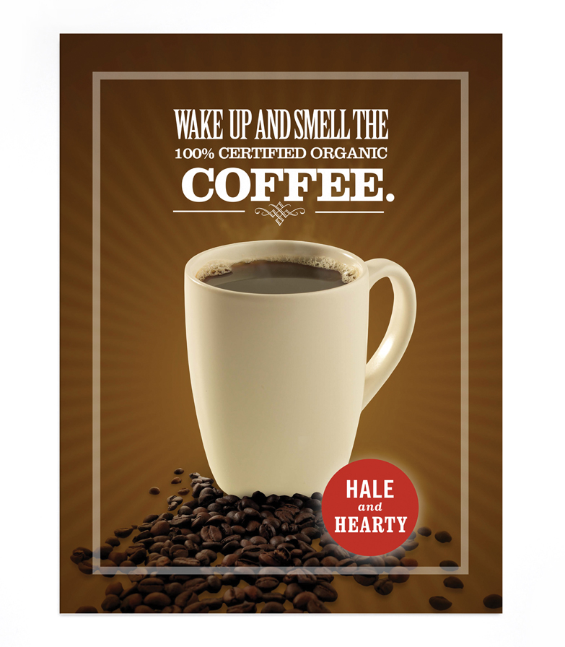
3.1.1 What brand of coffee is this advertisement advertising?
(1)
3.1.2 Which word in the advertisement suggests this coffee is healthy?
(1)
3.1.3 Give three reasons how you know the advertisement is about coffee.
(3)
QUESTION 4 – CARTOON
Look at the following cartoon and answer the questions that follows:
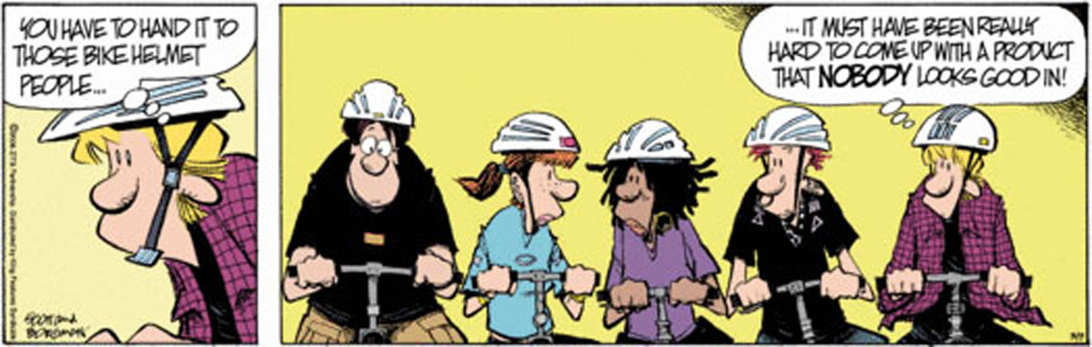
Read the following text and answer the questions.
4.1 Is the man in frame one thinking or talking? How do you know?
(2)
4.2 What do you call a person who rides a bicycle?
A. Biker
B. Cycler
C. Cyclist
(1)
4.3 What is the man’s impression of a bicycle helmet?
(1)
4.4 Why are they all wearing helmets?
(1)
[5]
QUESTION 5 – LANGUAGE
Look in the following passage for the answers to the questions that follow:
Text A
- Halle was born in Cleveland, Ohio, in the United States of America.
- Halle’s father was a heavy drinker who physically abused Halle’s mother and sister.
- He left the family home when Halle was/were four.
- Halle’s mother strugled to raise her daughters but encouraged Halle to do well at school.
- She was gifted academically and she stood out because she was very pretty.
- When she was 17, she won the first of many pageants, and in 1987 she came third in the Miss World Contest.

5.1 Write down two proper nouns from the passage.
(2)
5.2 Change the word “encouraged” into an abstract noun.
(1)
5.3 Write down a common noun from the passage.
(1)
5.4 Look at sentence 3. Use the correct word: (was or were).
(1)
5.5 Use the correct concord in the following sentences:
5.5.1 John and Adam is/are fans of Halle Barry.
(1)
5.5.2 Neither John nor his family has/have ever been to America.
(1)
5.5.3 All the children in the movie theatre love/loves Halle’s newest movie.
(1)
5.6 Name the punctuation mark used in the word “Halle’s”(sentence 2). Give a reason why it is used.
(2)
5.7 In sentence 4 there is a spelling mistake. Write down the incorrect word with the correct word next to it.
(1)
5.8 Write down the degrees of comparison for the word following words:
5.8.1 pretty
(2)
5.8.2 encouraged
(2)
[15]
TOTAL: 40

